|  |  |
| --- | --- |
|  | **FPT ACADEMY INTERNATIONAL**  **FPT – APTECH COMPUTER EDUCATION** |

**Centre Name: FPT-Aptech HCM.**

**Address: 391A Đ. Nam Kỳ Khởi Nghĩa, Phường 14, Quận 3, Tp. Hồ Chí Minh**

**AMAZING BRIDGES**

|  |  |  |
| --- | --- | --- |
| **Supervisor.** | Mr. Nguyễn Phát Tài | |
| **Batch.** | T1.2209.E0 | |
| **Group.** | **Group 3** | |
| **Serial No.** | **Enrollment Number** | **Student Name** |
| 1. | Student1421362 | Phạm Huy Hoàng |
| 2. | Student1420705 | Trịnh Tiến Đạt |
| 3. | Student1416122 | Trần Gia Toàn |
| 4. | Student1420714 | Huỳnh Ngọc Huy |
| **Duration** | Start date: Dec 14th, 2022 | End date: Jan 14th, 2023 |

**This is to certify that**

**Mr/Mrs:**

Phạm Huy Hoàng

Trần Gia Toàn

Trịnh Tiến Đạt

Huỳnh Ngọc Huy

**Has successfully designed & developed**

eProject: Amzing Bridges

**Submitted by: Phạm Huy Hoàng**

**Date of issue: Jan14th, 2023**

**Authorized Signature: Hoàng**

# TABLE OF CONTENTS

**TABLE OF CONTENTS 3**

**ACKNOWLEDGEMENT 5**

**SYNOPSIS 5**

**PROBLEM STATEMENT 5**

**CUSTOMER’S REQUIREMENTS SPECIFICATIONS (CRS) 7**

Objectives of the project: 7

Problem Statement: 7

Input to the system: 8

Output from the system: 8

Expected delivery date: 8

List of deliverables: 8

Hardware/ software requirements: 8

Hardware 8

Software 8

**SCOPE OF THE WORK (IN BRIEF)** 9

1. Home page: 9

2. Types Of Bridges: 9

3. Gallery: 9

4. Detail page: 9

5. Other pages, widgets: 9

**ARCHITECTURE AND DESIGN OF THE SYSTEM 10**

**DIAGRAM OF WEBSITE 11**

**TASK SHEET REVIEW 1 12**

**SITE MAP OF THE WEBSITE 14**

**MOCK OF THE WEBSITE 15**

1/Home page 15

2/ Bridges Categories 16

3/ Bridge Detail 17

4/ Gallery 18

5/ About Us 19

**TASK SHEET REVIEW 2 20**

**WEBSITE DESCRIPTION 21**

Homepage: 21

Description: 21

Screenshot: 21

Category 24

Description: 24

Screenshot: 24

Search: 26

Description: 26

Screenshot: 26

Bridge Detail: 27

Description: 27

Screenshot: 27

Gallery: 30

Description: 30

Screenshot: 30

Pages 32

About Us: 32

Contact Us: 33

Description: 33

Screenshot: 33

**Source Code of HTML, CSS, JavaScript and Angular JS** 35

HTML: 35

CSS: 36

JSon: 37

JS: 38

**TASK SHEET REVIEW 3** 40

# ACKNOWLEDGEMENT

On behalf of all the members of Group 3, I would like to thank all of you for your hard work, fearless of difficulties, working together to make this eProject complete. Especially, Teacher Nguyen Phat Tai, he has helped us a lot from the first days of coming to FPT Aptech. With this eProject, Teacher have guided us very enthusiastically and seriously, thanks to your guidance we were able to complete this project, and thank you for standing with us to overcome it. We would like to thank you very much. Besides, I would like to thank all the members of Team 3, each team member has worked continuously for 4 weeks to complete this project. Finally, we would like to thank our family for always supporting us, creating the best conditions for us to focus on eProject, and believing in the dreams we pursue.

# SYNOPSIS

A bridge is a structure built to connect two places without blocking the road below it. A bridge can be built over a road, body of water, or valley. Bridges are made of different materials and have different designs. Bridges can be classified according to the weight holding mechanism, the materials used and the style, and other parameters. The most commonly used classification method is their weight capacity. Some common bridge types include arch bridges, girder bridges, truss bridges, suspension bridges, and cantilever bridges. This Project will show you the other aspect, which rank all the famous bridge in the world to type of: longest, tallest, and oldest, most visited, etc.

For many people, bridges are just convenient structures connecting two points across a river or a valley. But, they can be much more. Some of the most splendid and beautiful bridges are among the most iconic sights in the world. And now let's explore the world's bridges together!

# PROBLEM STATEMENT

The Web site is to be created based on the following requirements:

1. The Home Page should be created making use of Sections with a suitable logo, the header section can be added which will show images of famous bridges.
2. The site must contain the links to navigate through any category for the information.
3. Links of monuments can be categorized by zone wise like (Longest, Tallest, Highest, Oldest, Most Visited, etc.) apart from country wise link can be added.
4. Clicking on any monument should open the page about the monument with it’s location displayed using GeoLocation API on the maps.
5. History and information of the bridges can be added along with the images.
6. Gallery section can be added for viewing different images.
7. Feedback must be allowed to enter by the viewer
8. Site map, Gallery, about us, Queries link, Contact us link must be added.
9. The complete historic reason and its description must be allowed to get download as PDF or DOC file.
10. The advertise section of bus, flights can be included for reaching the places.

# CUSTOMER’S REQUIREMENTS SPECIFICATIONS (CRS)

**Client:**

**AMAZING BRIDGES**

## Objectives of the project:

The Objective of this program is to give a sample project to work on real life projects. These applications help you build a larger more robust application.

The objective is not to teach you HTML/JavaScript/Dreamweaver/HTML5 but to provide you with a real life scenario and help you create basic applications using the tools.

This project is meant for students who have completed the module of HTML5. These programs should be done in the Lab sessions with assistance of the faculty if required.

It is very essential that a student has a clear understanding of the subject. Students should go through the project and solve the assignments as per requirements given.

## Problem Statement:

Amazing Bridges website will present the information about the various famous bridges throughout the world. The information behind this creation must be added.

The information of amazing bridges can be categorized based on zone wise (Longest, Tallest, Highest, Oldest etc.).

You are supposed to create a website for them with the below mentioned requirement specifications.

The website is to be developed for the Windows Platform using HTML5, JavaScript and Geolocation. The site should work well in all leading browsers including Chrome, IE, Firefox etc.

## Input to the system:

Provide information for clients about famous bridges in the world categorized into longest, tallest, highest, most vistied… This web site show the information include history and photos of these bridges, and also how to travel there by bus and flight.

## Output from the system:

* A menu that will categorize all the functions of the site.
* Display the list of available bridges category wisely.
* List of articles about the famous bridges in the world.
* Besides the above requirements, the site should have look and feel as per professional standard gallery.

## Expected delivery date:

Jan14th, 2023

## List of deliverables:

* Document Word.
* Video clips
* User Guide.
* Source code.

## Hardware/ software requirements:

### Hardware

* A minimum computer system that will help you access all the tools in the courses is a Pentium 166 or better.
* 64 Megabytes of RAM or better.

### Software

* Notepad/HTML editor.
* Visual Studio Code.
* IE 5.0/ Netscape 6.0.

# SCOPE OF THE WORK (IN BRIEF)

After a long and detailed discussion, our group has decided to create a website contain the following web pages:

1. **Home page**:

Welcome to website Amazing Bridges and display core values Amazing Bridges brings through Slider.

Navigation and search bar for user free to explore the website.

1. **Types Of Bridges:**

Categories of bridges by Slider:

* The Highest Bridges
* The Longest Bridges
* The Oldest Bridges
* The Most-visited Bridges

1. **Gallery:**

Album collection of top famous bridges and was categorized to each type of bridges.

Each photo display brief information of bridges.

1. **Detail page**:

* Brigde Info
* Photos
* History and information
* Location
* Bus + Flights Guidance
* Download
* You may like
* Comment

1. **Other pages, widgets**:

* About us.
* Contact us
* Register newsletter
* Site Map

ARCHITECTURE AND DESIGN OF THE SYSTEM

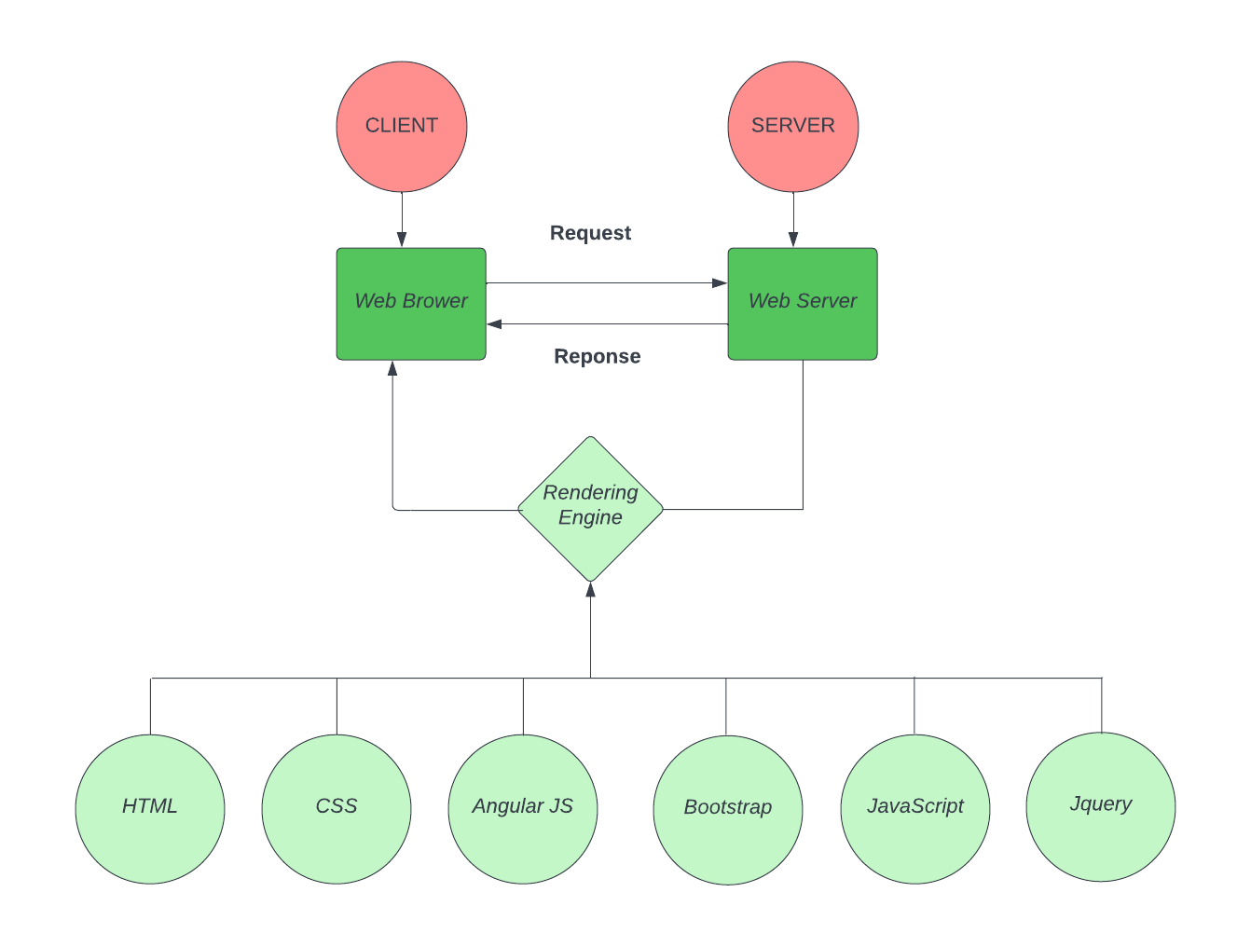

# DIAGRAM OF WEBSITE

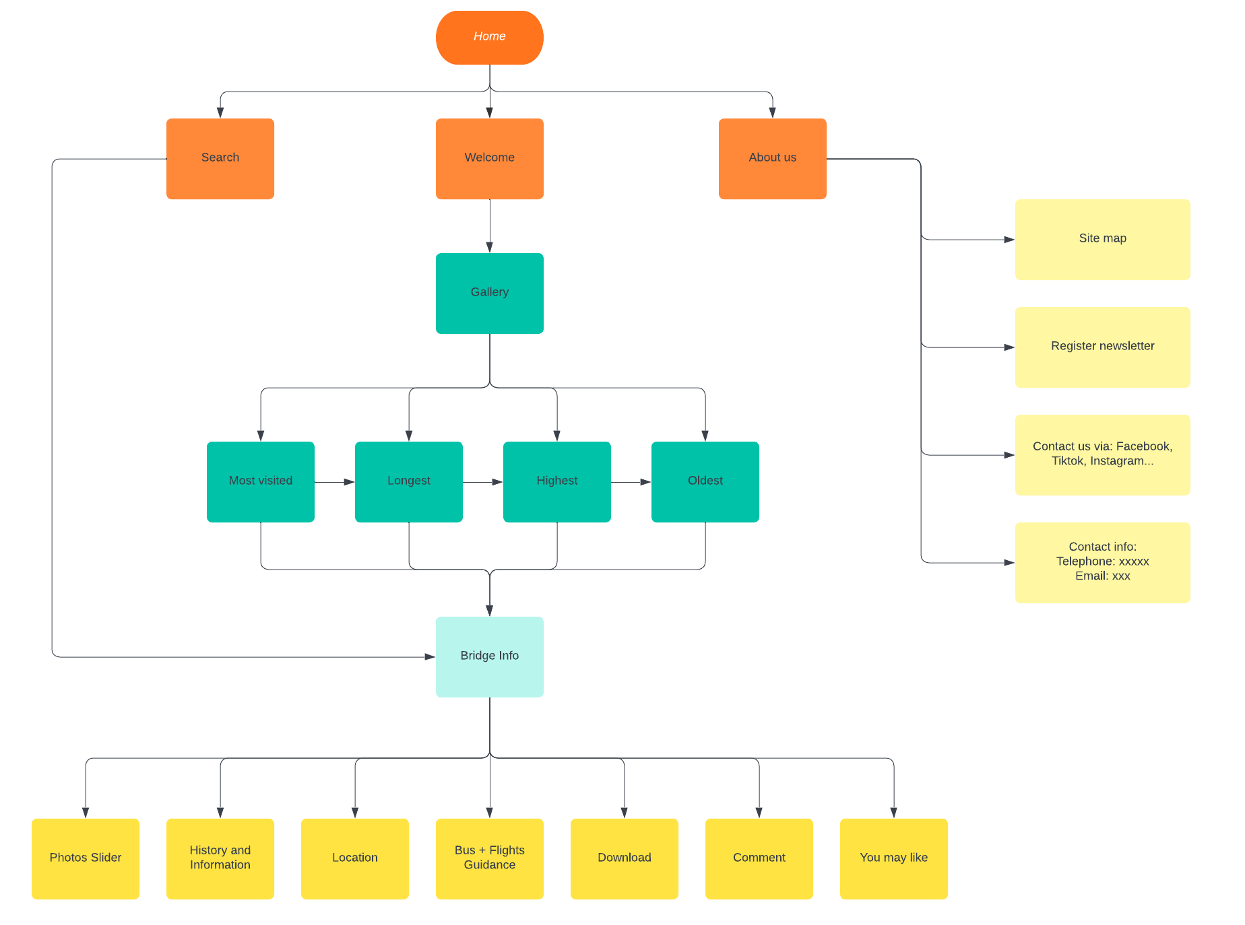

# TASK SHEET REVIEW 1

|  |  |  |  |  |  |  |  |
| --- | --- | --- | --- | --- | --- | --- | --- |
| **Project Ref. No.:**  **eP/Advertisement Portal Management**  **System/01** | | **Project Title:** | **Activity Plan Prepared By:** | **Date of Preparation of Activity Plan:** | | | |
| **Sr.**  **No.** | **Task** | **Actual Start Date** | **Actual Days** | **Team Mate Names** | **Status** |
| 1 | Problem Statement | Amazing Bridges | Hoàng | 14-Dec-2022 | 2 | Hoàng, Toàn | Completed |
| 2 | Analysis of the AMAZING BRIDGES requirements | 14-Dec-2022 | 3 | Hoàng, Toàn | Completed |
| 3 | The scope of the work | 14-Dec-2022 | 2 | Hoàng, Toàn, Đạt | Completed |
| 4 | Architecture and design of the system | 14-Dec-2022 | 1 | Hoàng, Toàn, Huy | Completed |
| 5 | Diagram of the website | 14-Dec-2022 | 1 | Hoàng, Toàn, Đạt | Completed |
| 6 | Task Sheet | 14-Dec-2022 | 1 | Toàn, Đạt | Completed |
| **Date: December 21st, 2022** | | | | | | | |
| Signature of the Instructor:  **Mr. Nguyễn Phát Tài** | | | | Signature of the Leader:  **Mr. Phạm Huy Hoàng** | | | |

# SITE MAP OF THE WEBSITE

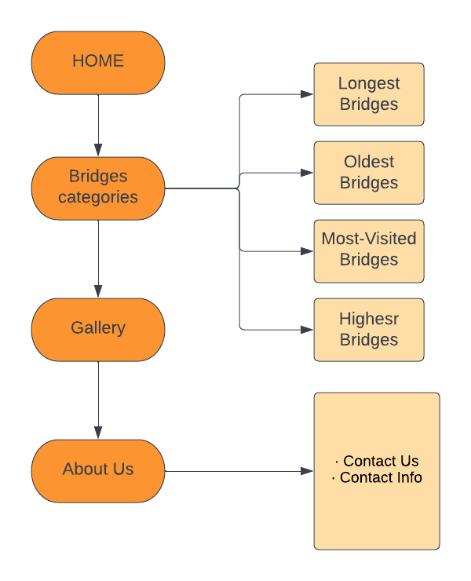

# MOCK OF THE WEBSITE

## 1/Home page

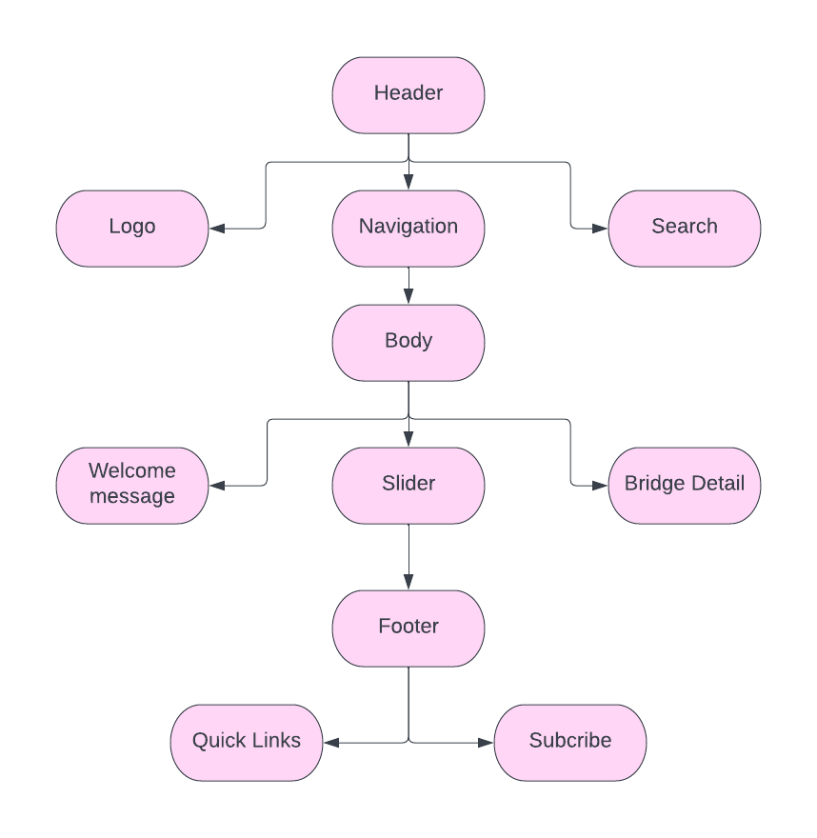

## 2/ Bridges Categories

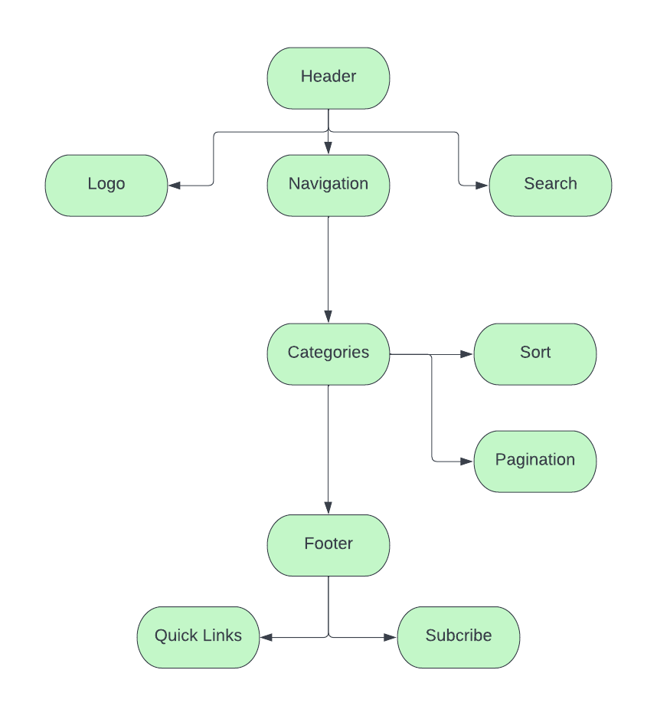

## 3/ Bridge Detail

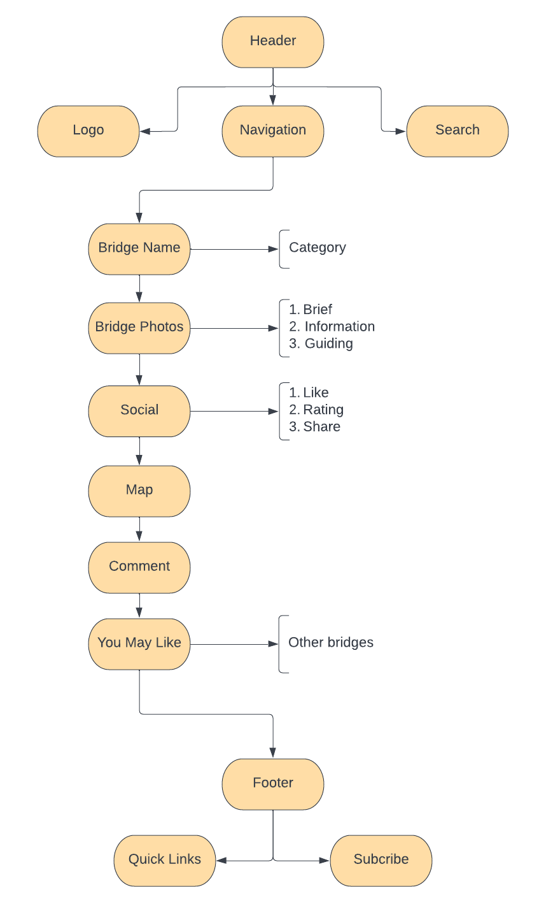

## 4/ Gallery

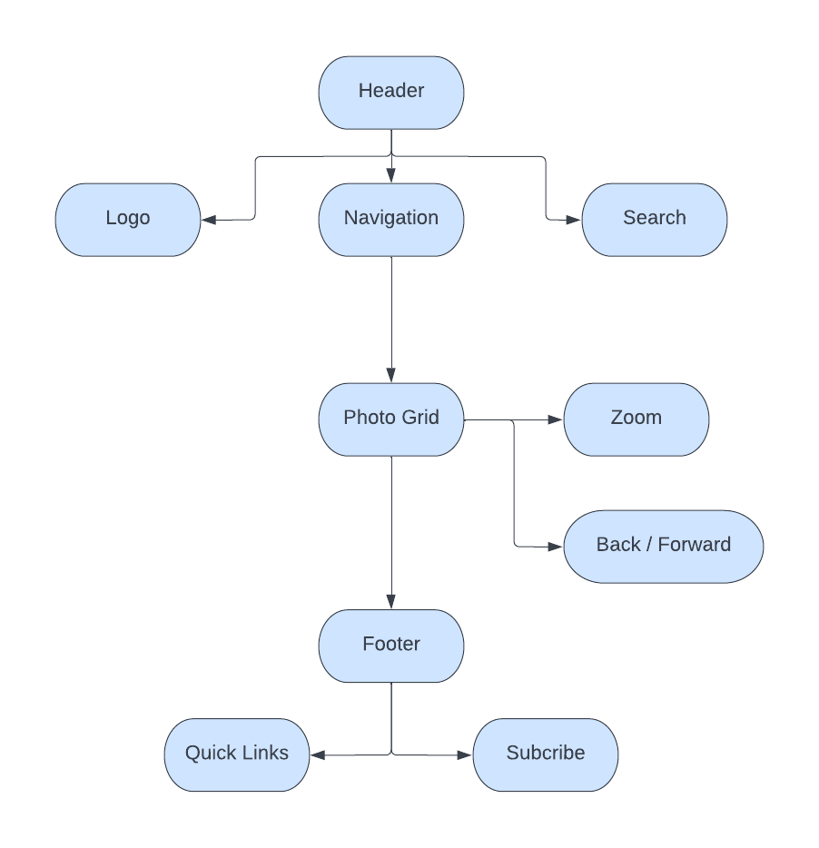

## 5/ About Us

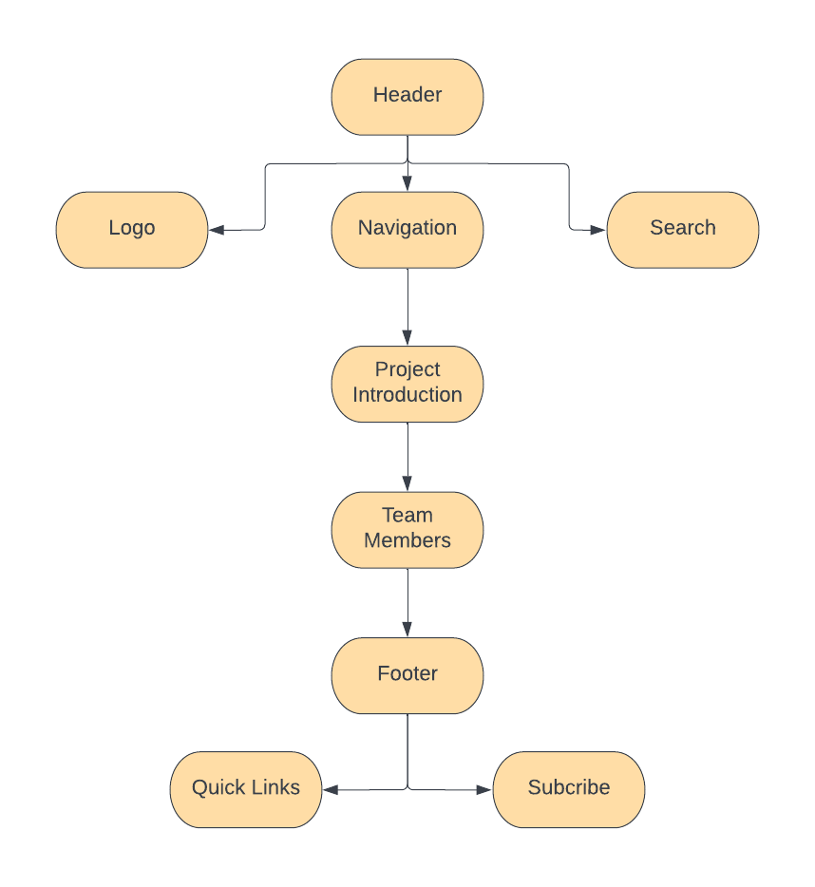

# TASK SHEET REVIEW 2

|  |  |  |  |  |  |  |  |
| --- | --- | --- | --- | --- | --- | --- | --- |
| **Project Ref. No.:**  **eP/Advertisement Portal Management**  **System/01** | | **Project Title:** | **Activity Plan Prepared By:** | **Date of Preparation of Activity Plan:** | | | |
| **Sr.**  **No.** | **Task** | **Actual Start Date** | **Actual Days** | **Team Mate Names** | **Status** |
| 1 | Edit Home page | Amazing Bridges | Hoàng | 20-Dec-2022 | 1 | Hoàng | Completed |
| 2 | JSON file | 24-Dec-2022 | 1 | Toàn,  Hoàng | Completed |
| 3 | Pages (About us, contact, gallery..v.v..) | 26-Dec-2022 | 1 | Hoàng,  Toàn | Completed |
| 4 | Site map and mock of the website | 1. Dec-2022 | 1 | Hoàng | Completed |
| 5 | Task Sheet | 28-Dec-2022 | 1 | Đạt, Huy | Completed |
| **Date: December 28th, 2022** | | | | | | | |
| Signature of the Instructor:  **Mr. Nguyễn Phát Tài** | | | | Signature of the Leader:  **Mr. Phạm Huy Hoàng** | | | |

# WEBSITE DESCRIPTION

## Homepage:

**Description:**

Display following information:

* Welcome message
* Featured slides:
* Bridges photo
* Bridges description
* Click to explore
* Naviation
* Footer
* Darkmode

**Screenshot:**

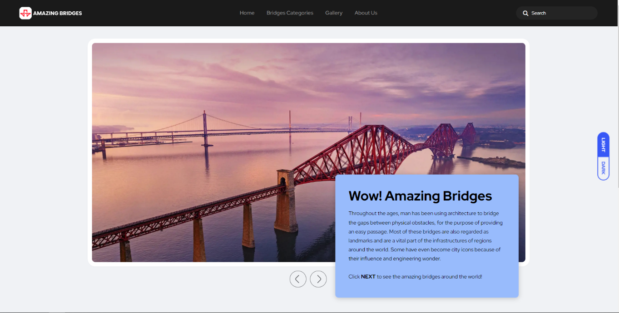

*Homepage*

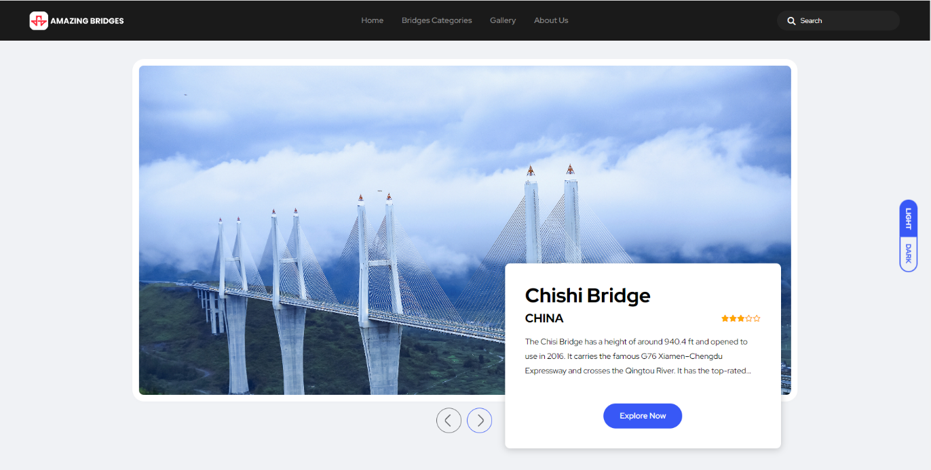

*Featured slides*

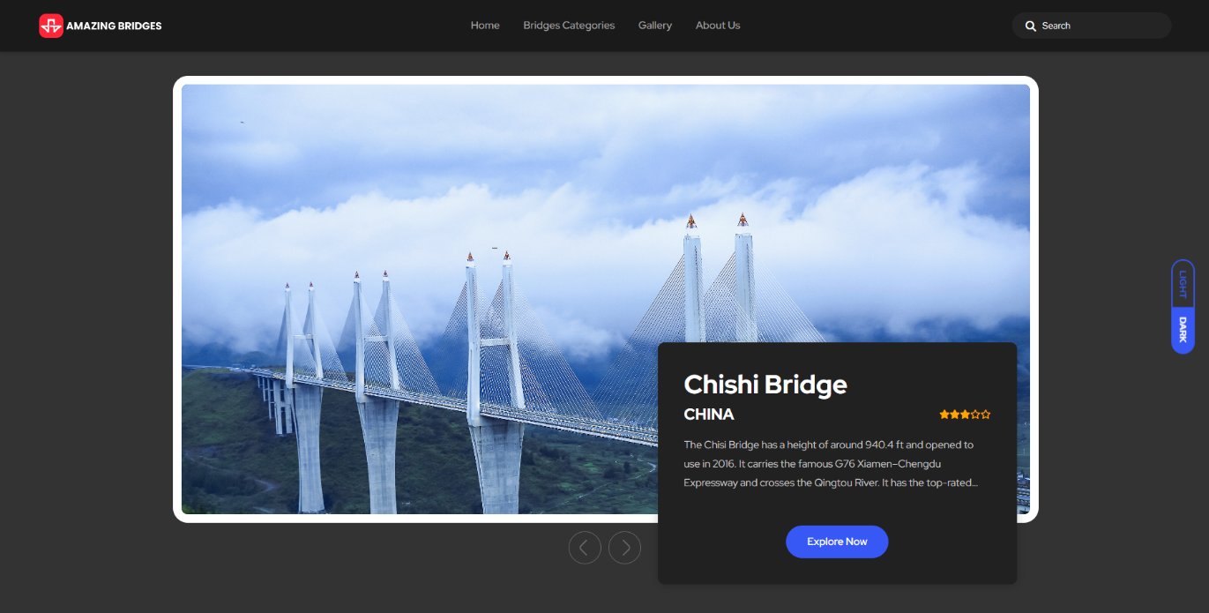

*Featured slides in dark mode*

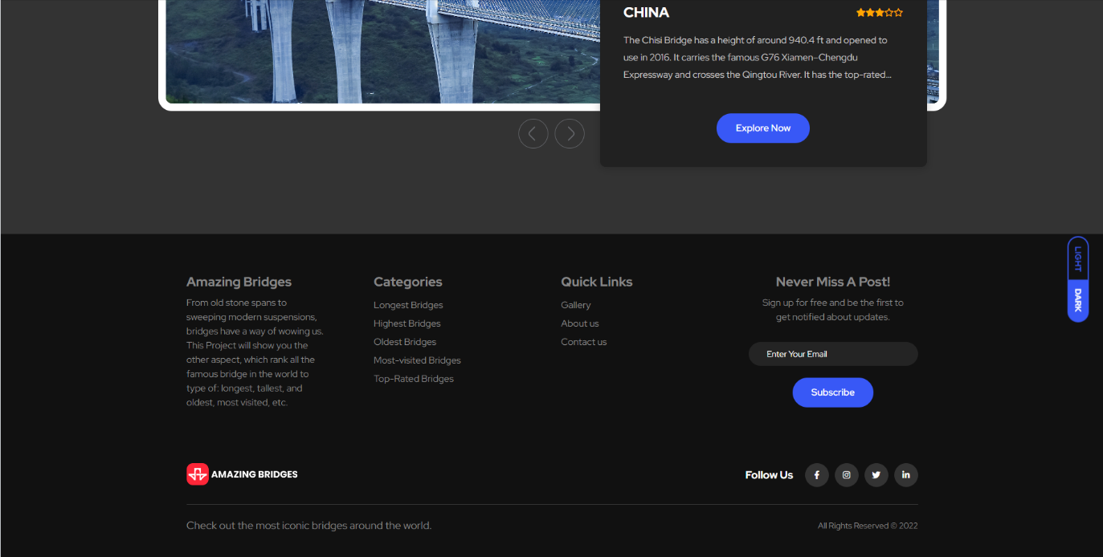

*Footer*

## Category

**Description:**

Display following information:

* Content: Variety of bridges
* Sort
* Pagination
* Dark mode

**Screenshot:**

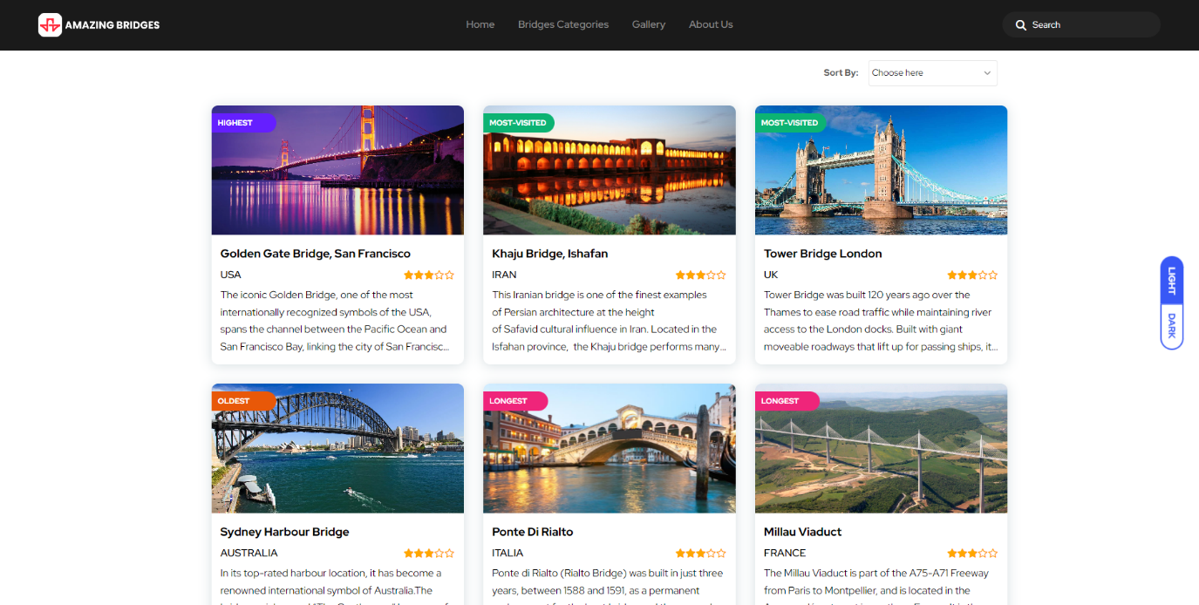

*Categories*

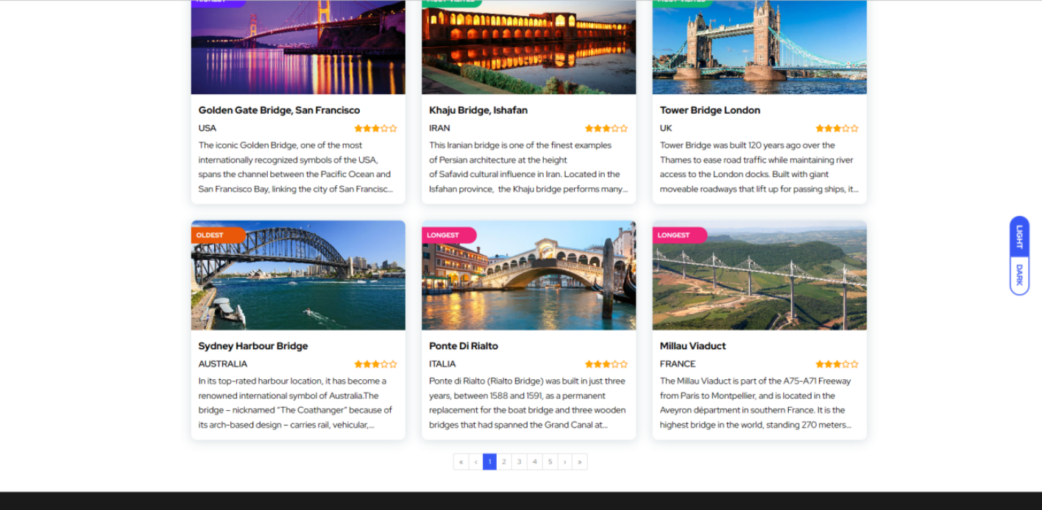

*Pagination*

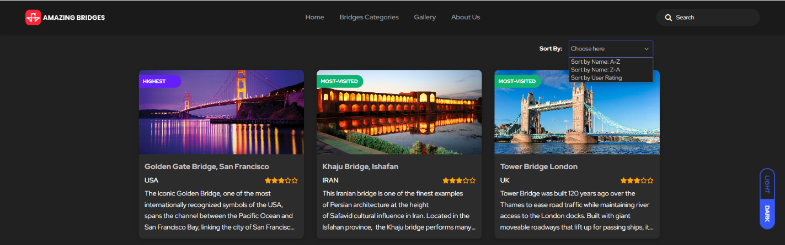

*Sort in dark mode*

## Search:

**Description:**

Search for bridges from any where of website, can search by name, country or description.

**Screenshot:**

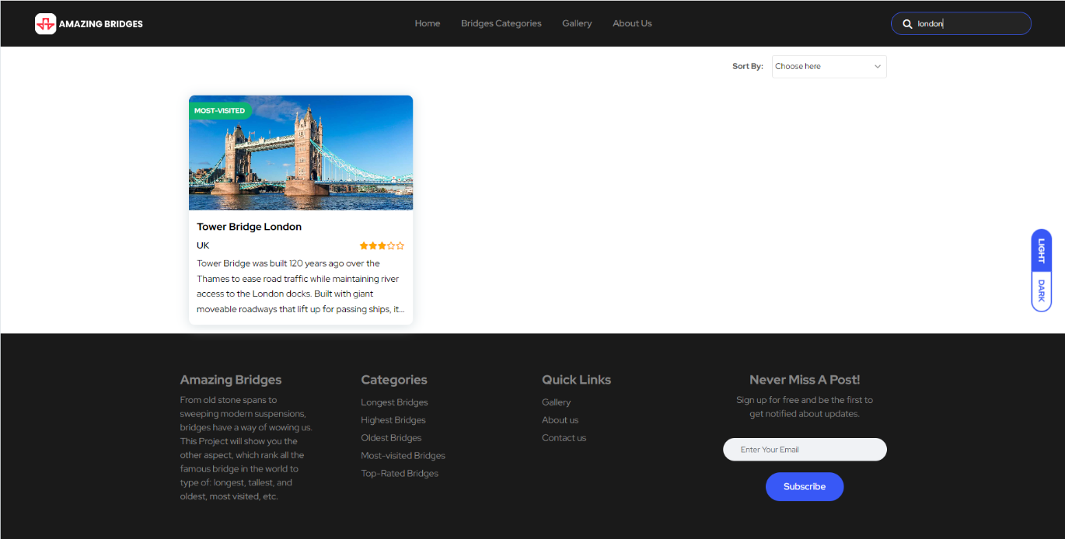

*Search result*

## Bridge Detail:

**Description:**

Display detail information of selected bridge:

* Category
* Name
* Photo
* At glance tabs:
* Brief: short description
* Information: dimension of bridges, year built, visitor per year…
* Guiding: the nearest airport and bus station to the bridge
* Like and star rating
* Share on social media
* Save information as PDF
* Map with Geolocation
* Comment
* You may like (to see other bridges)

**Screenshot:**

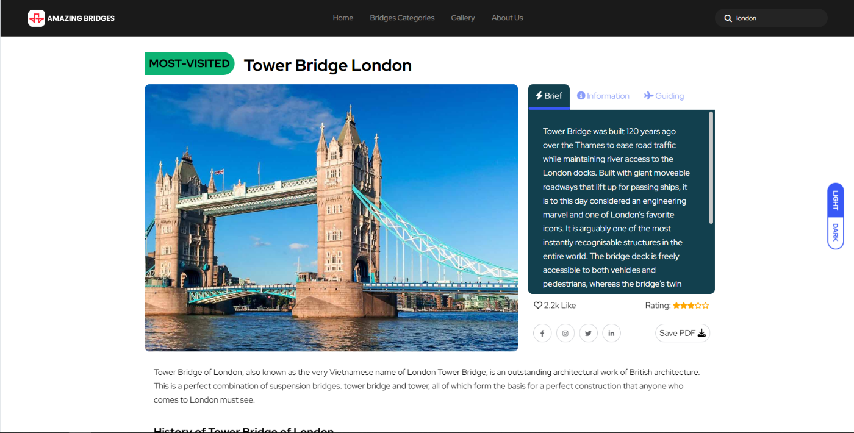

*Bridge detail at a glance*

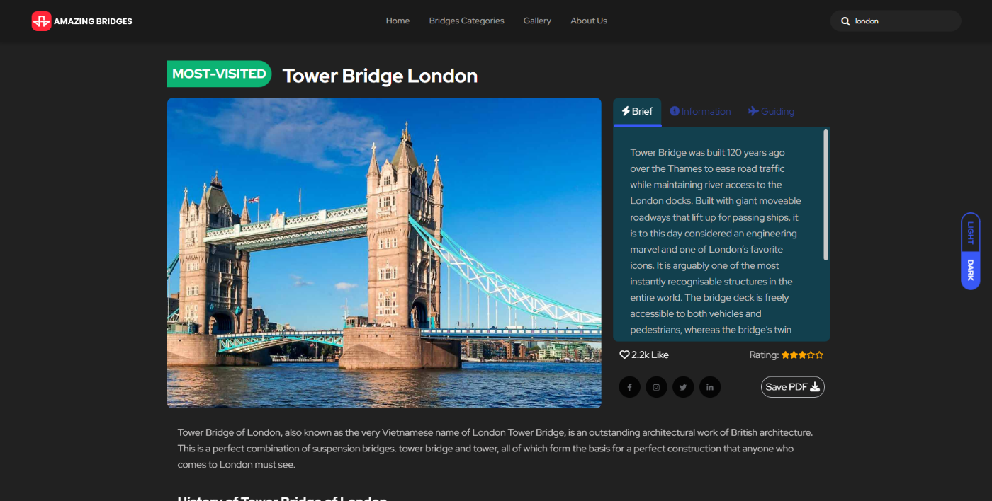

*Bridge detail in dark mode*

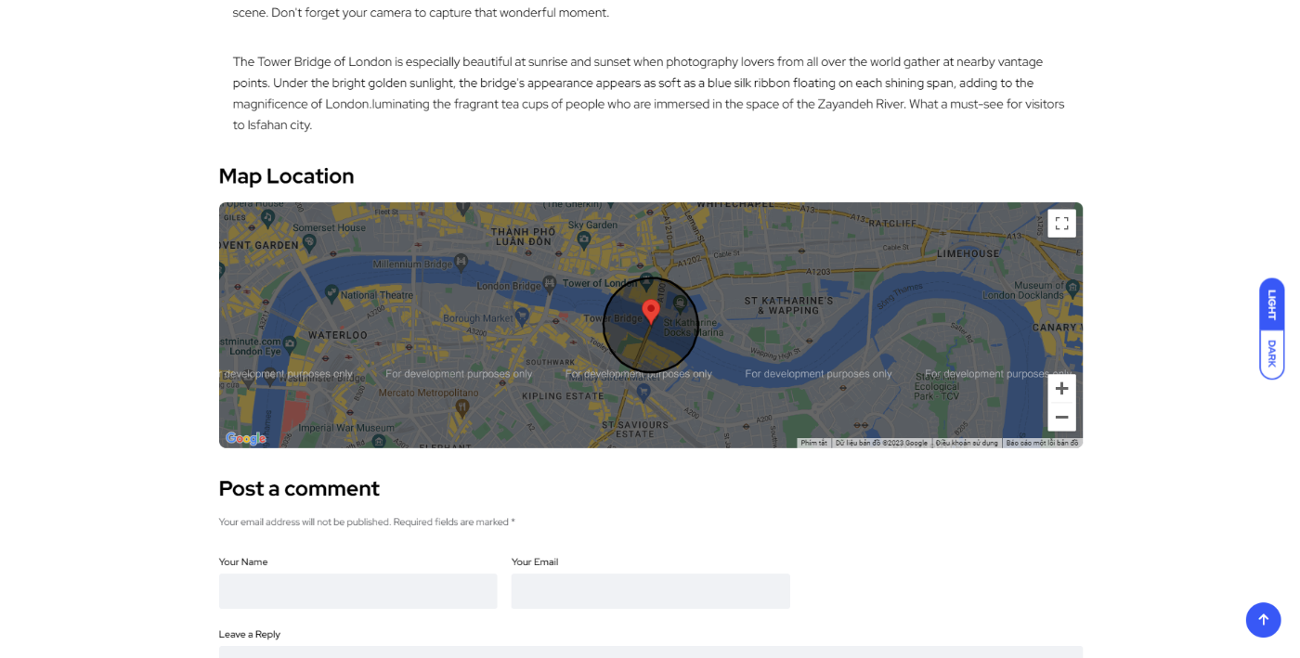

*Map with Gelocation*

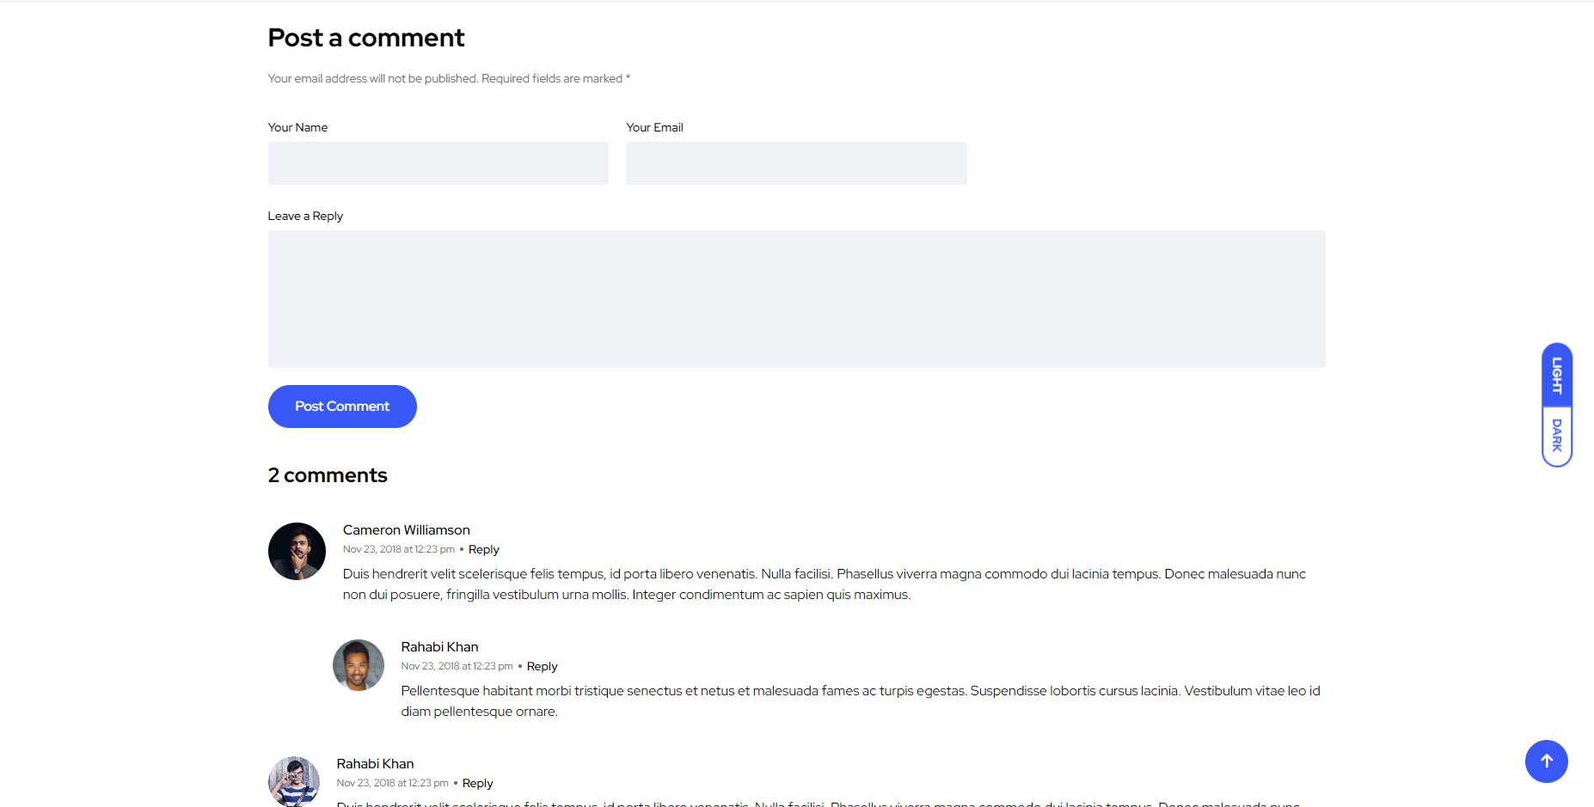

*User comment*

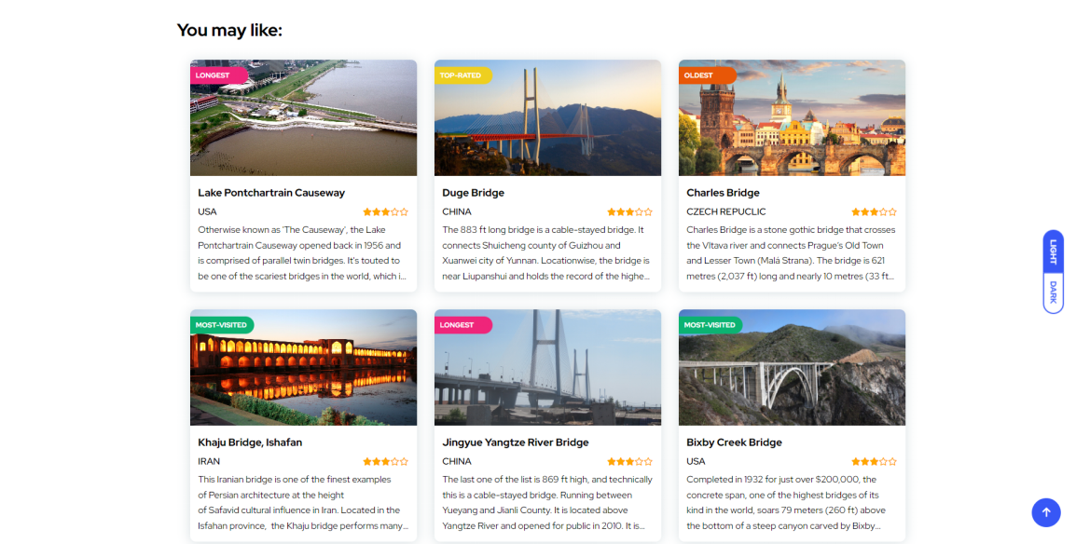

*You may like (to see other bridges)*

## Gallery:

**Description:**

Gather all photos of the beautiful bridges in the website, which show:

* Name of the bridge
* Country
* Total photos.

**Screenshot:**

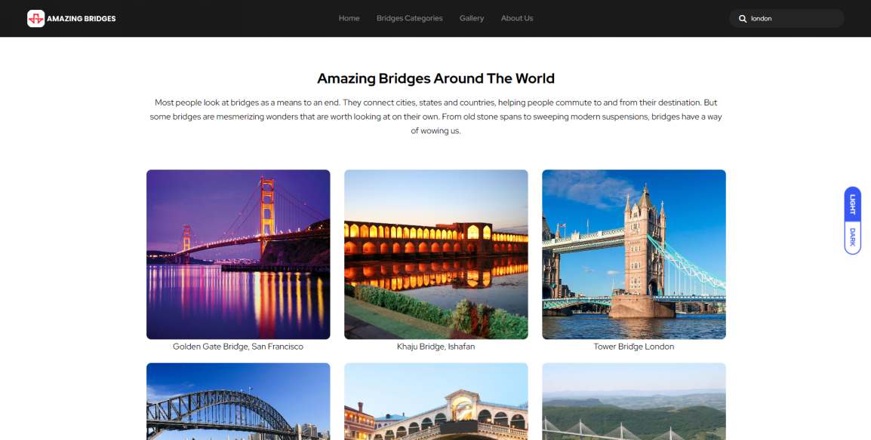

*Gallery*

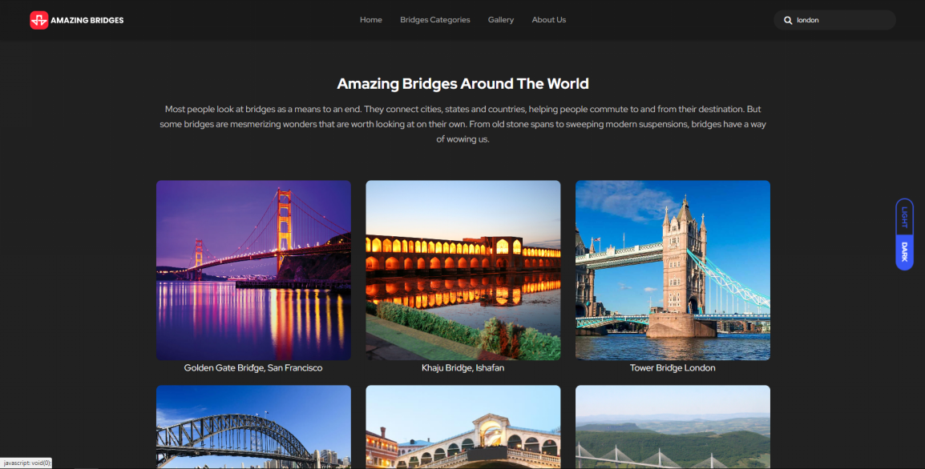

*Gallery in dark mode*

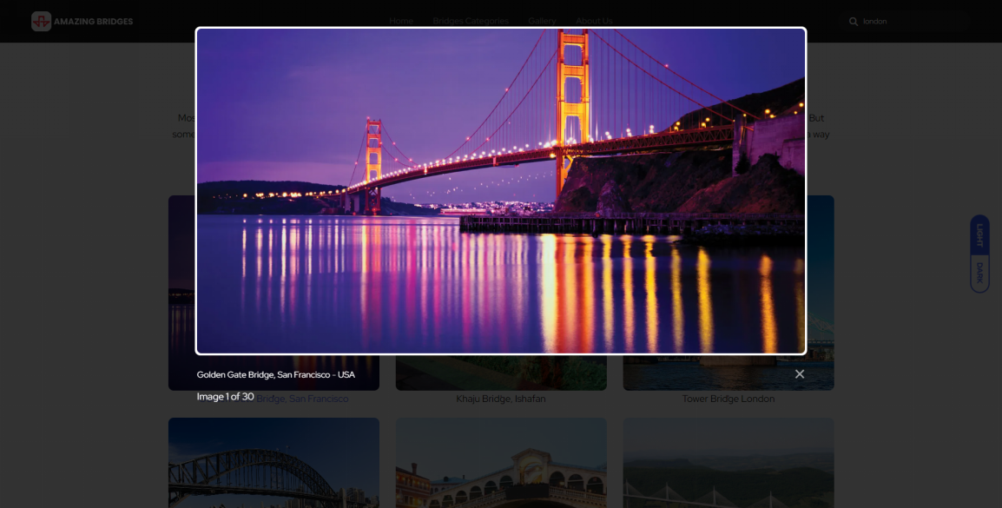

*Photo zoomed*

## Pages

* **About Us:**

**Description:**

* Introduce company commission and members.

**Screenshot:**

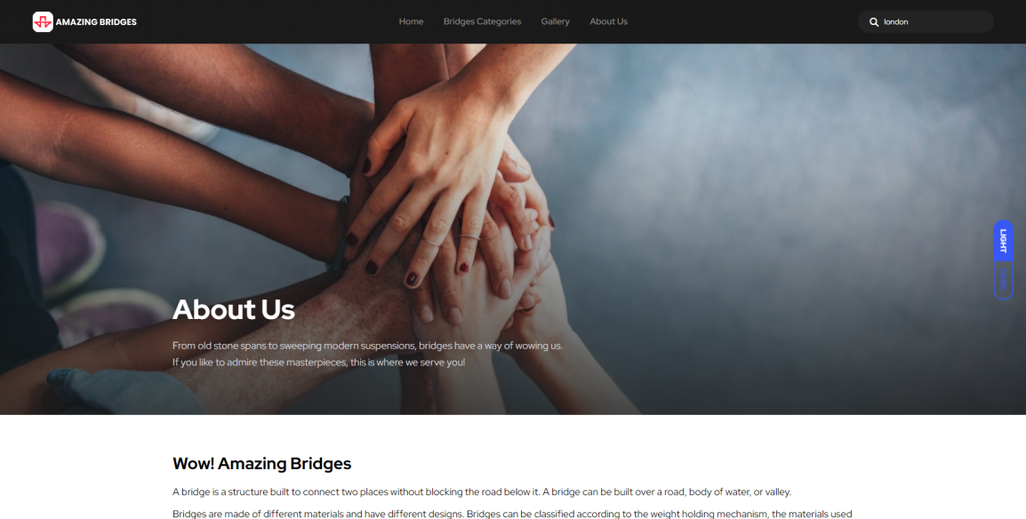

*Introduce company commission*

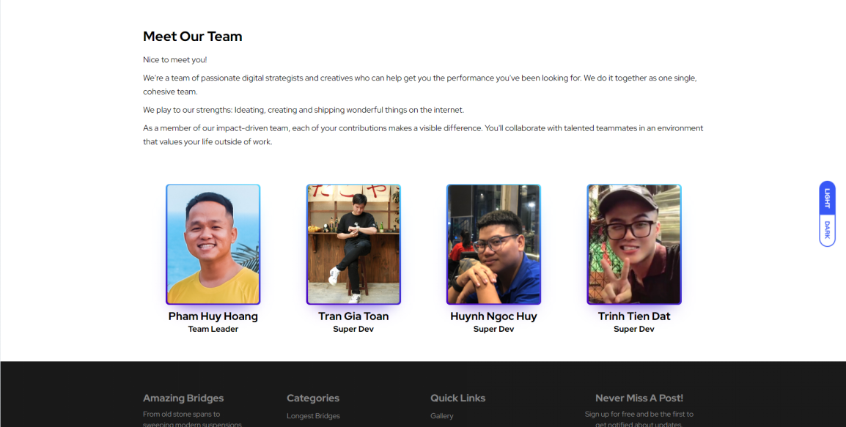

*Team members*

* **Contact Us:**

**Description:**

* Contact information.
* Contact form

**Screenshot:**

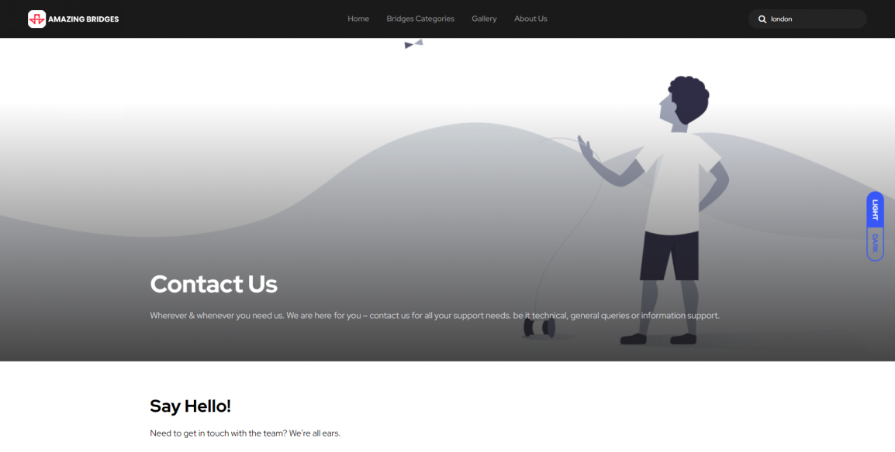

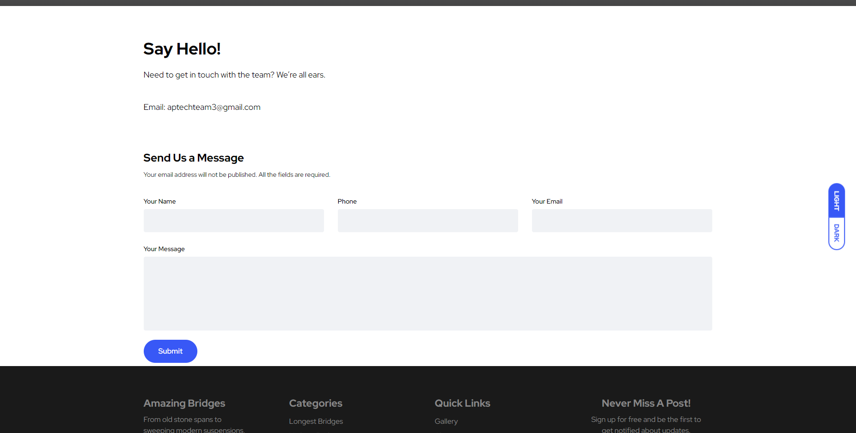

## Source Code of HTML, CSS, JavaScript and Angular JS

### HTML:

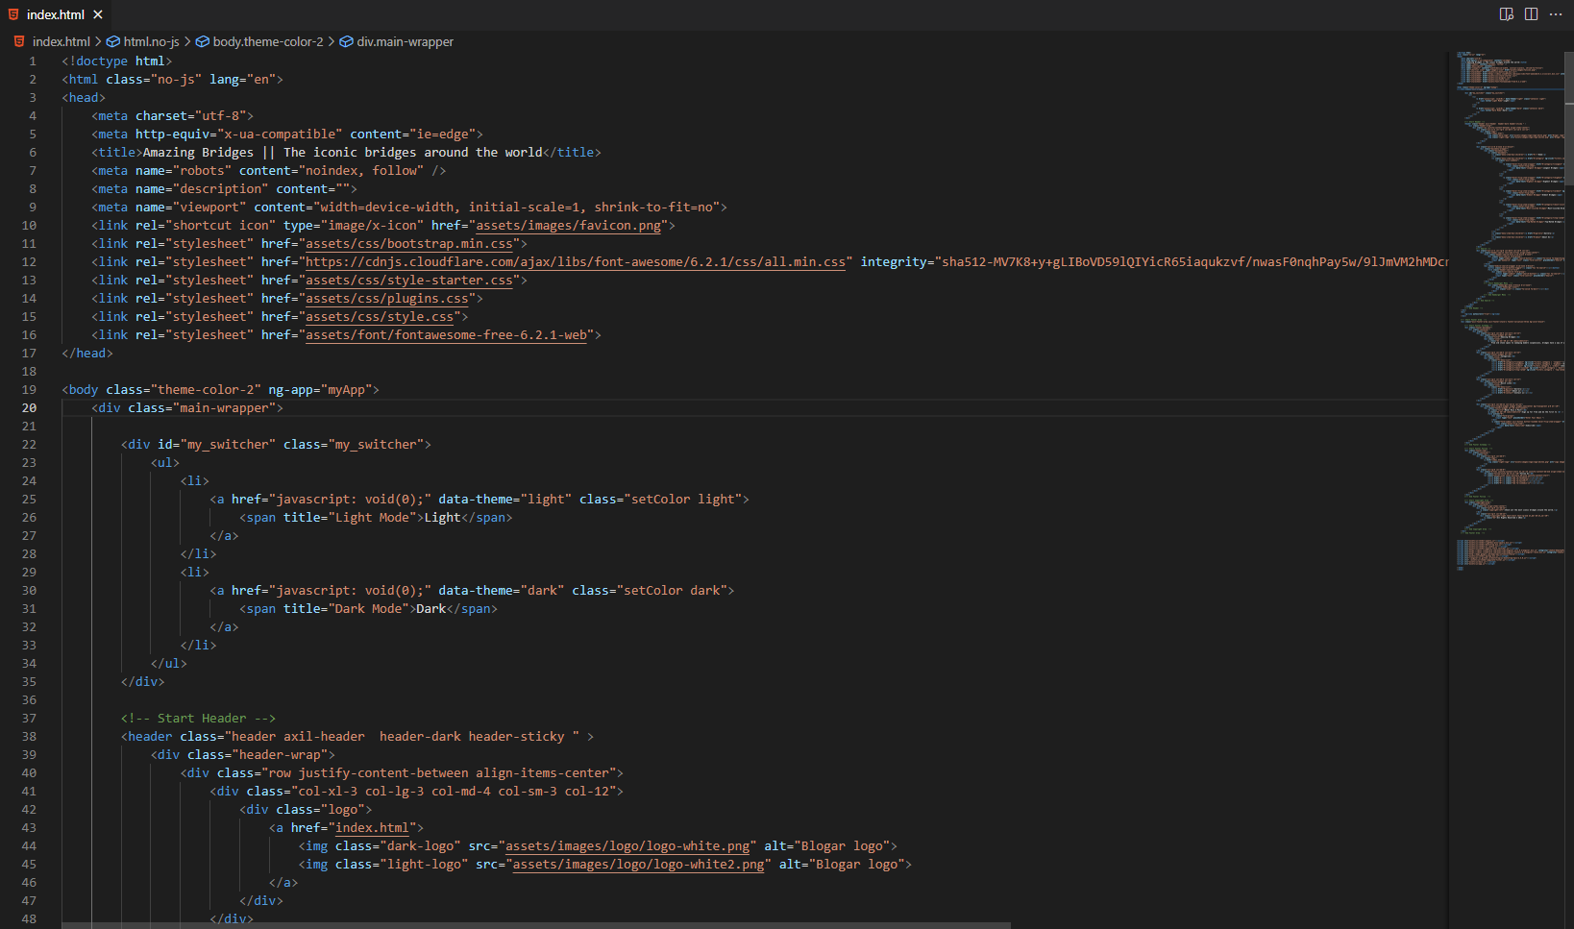

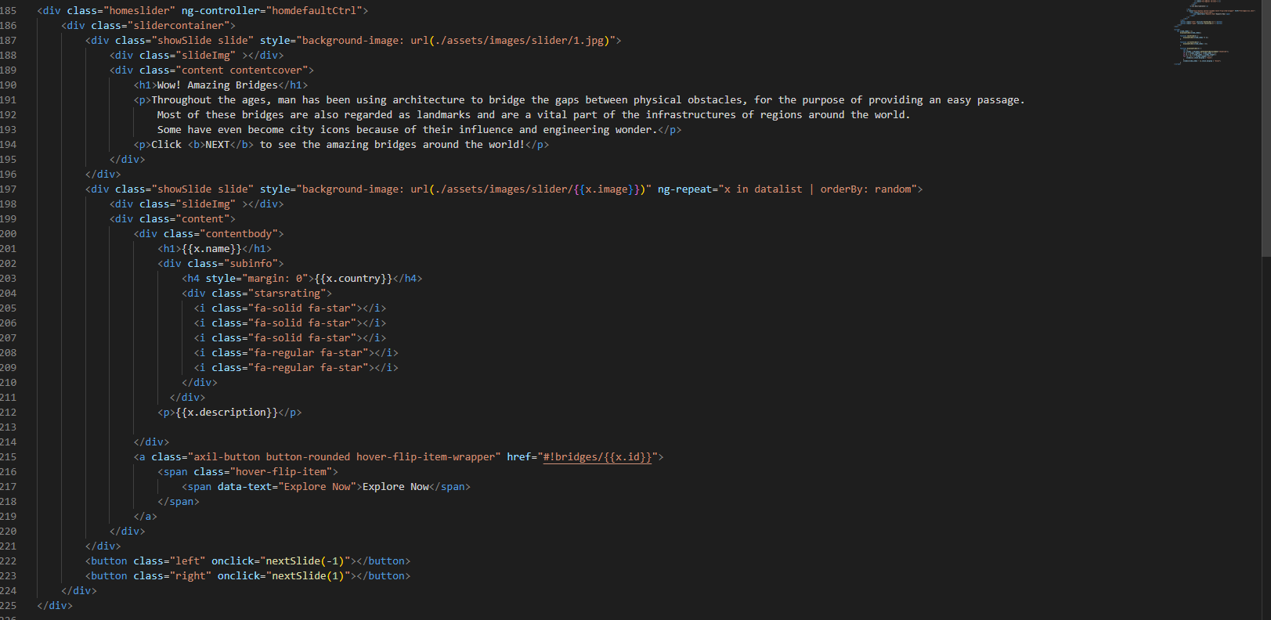

**CSS:**

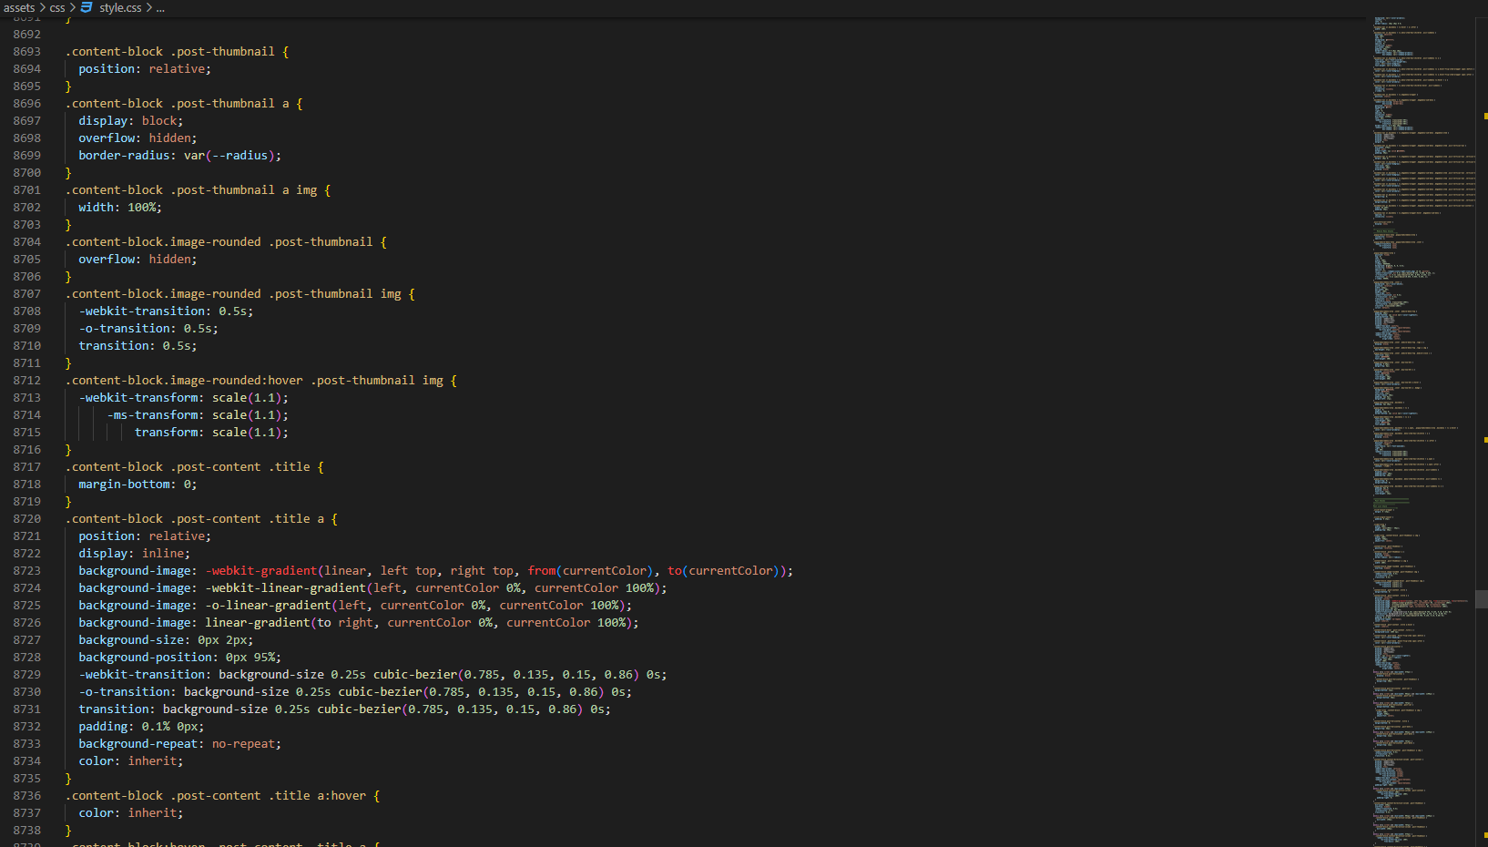

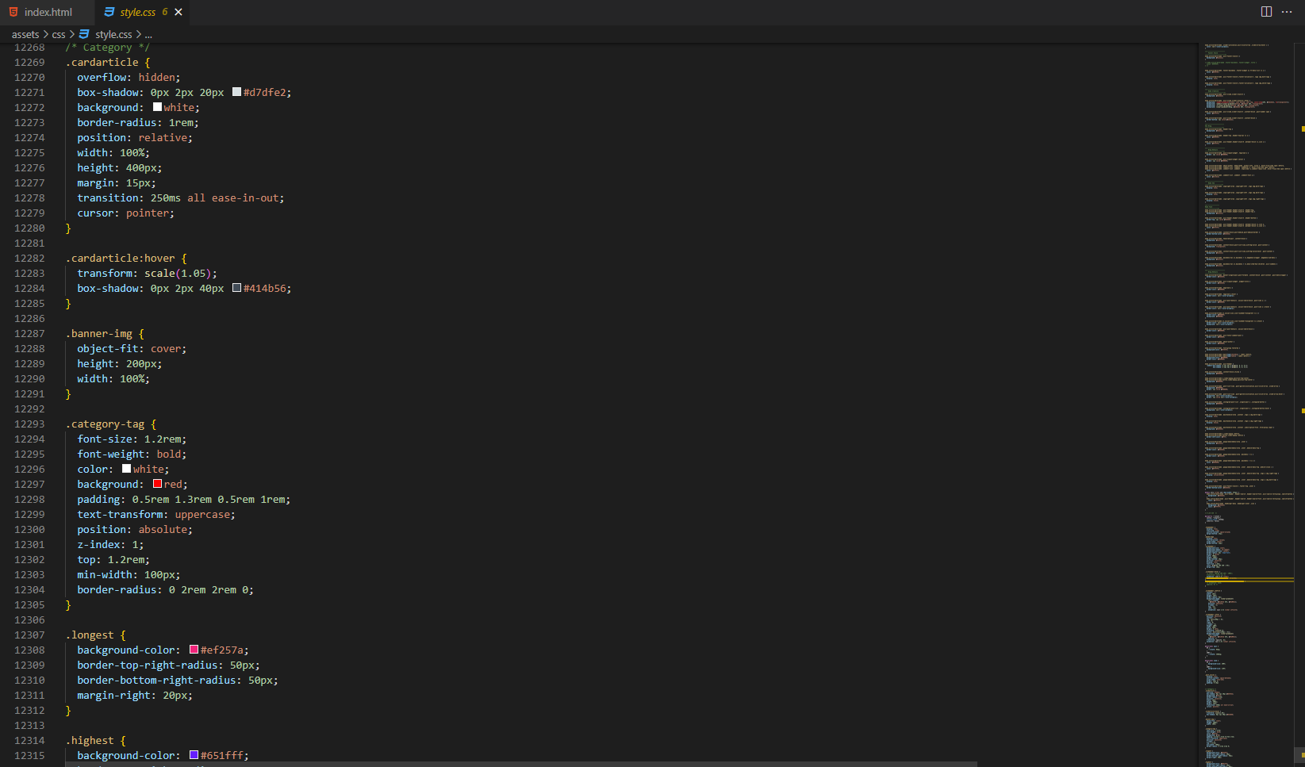

**JSon:**

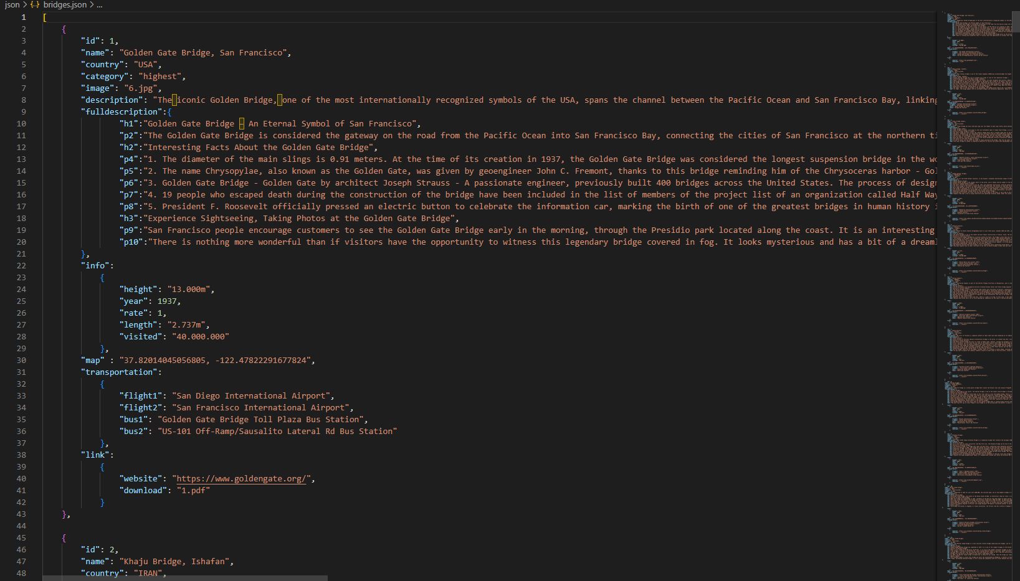

**JS:**

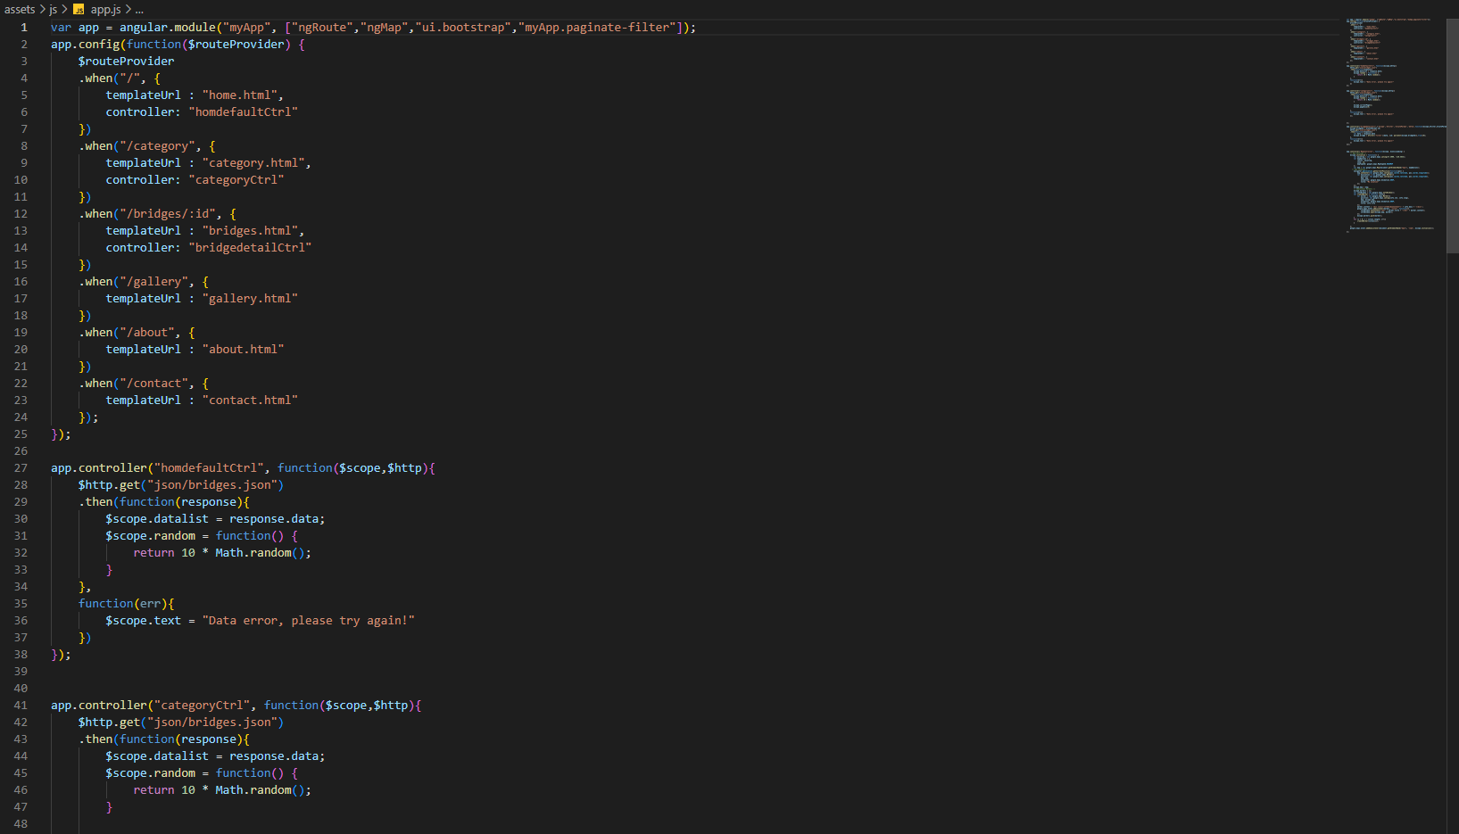

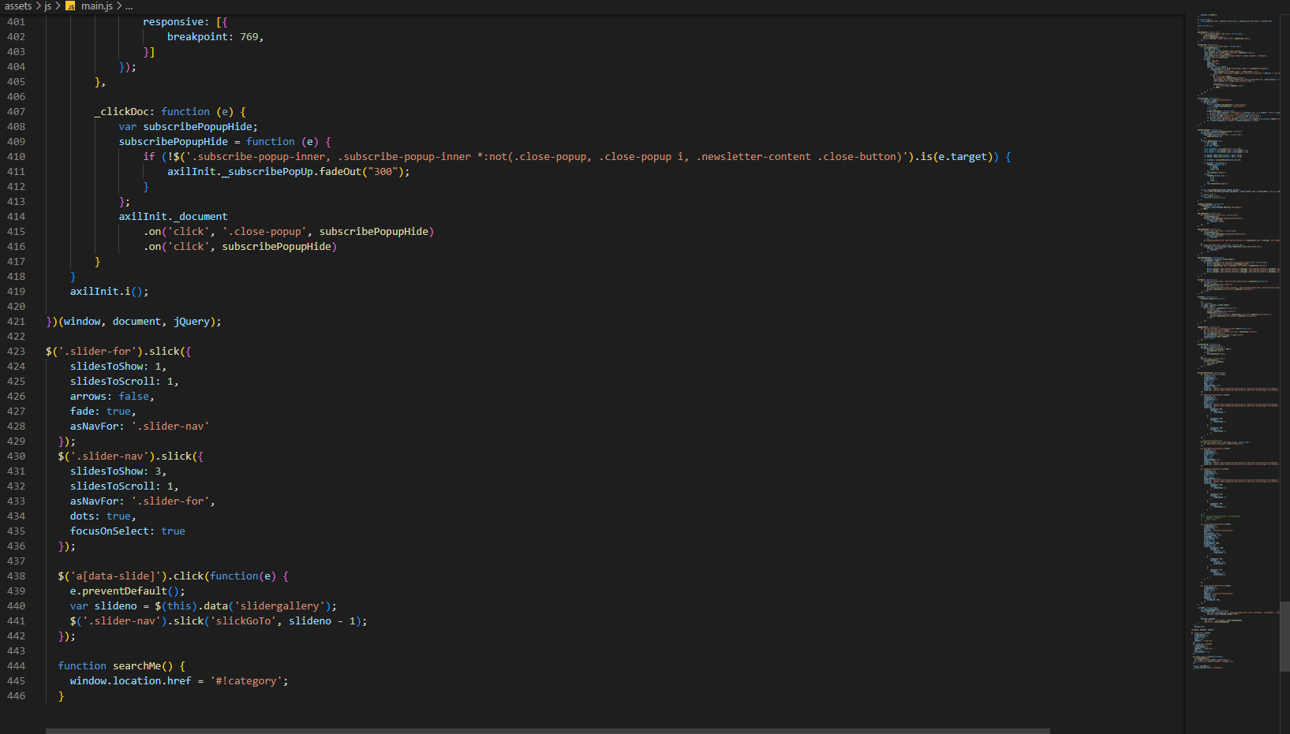

## TASK SHEET REVIEW 3

|  |  |  |  |  |  |  |  |
| --- | --- | --- | --- | --- | --- | --- | --- |
| **Project Ref. No.:**  **eP/Advertisement Portal Management**  **System/01** | | **Project Title:** | **Activity Plan Prepared By:** | **Date of Preparation of Activity Plan:** | | | |
| **Sr.**  **No.** | **Task** | **Actual Start Date** | **Actual Days** | **Team Mate Names** | **Status** |
| 1 | Update new features | Amazing Bridges | Hoàng | 02-Jan-2023 | 2 | Hoàng, Toàn | Completed |
| 2 | Dark mode | 03-Jan-2023 | 2 | Hoàng | Completed |
| 3 | Optimize code | 04-Jan-2023 | 3 | Hoàng | Completed |
| 4 | JSON | 03-Jan-2023 | 1 | Toàn | Completed |
| 5 | Video demo | 01-Jan-2023 | 2 | Hoàng | Completed |
| 6 | Task sheet | 03-Jan-2023 | 1 | Huy, Đạt | Completed |
| **Date: January 6th, 2023** | | | | | | | |
| Signature of the Instructor:  **Mr. Nguyễn Phát Tài** | | | | Signature of the Leader:  **Mr. Phạm Huy Hoàng** | | | |